Design a Dobble deck with exactly two pictures (or numbers) on each card. Remember, each pair of cards should have one picture in common, and each pair of pictures should have one card in common.

Design a Dobble deck with exactly three pictures (or numbers) on each card.

Draw two lines. How many points do they have in common?

Can you find two lines that have a different number of points in common?

What is the slope of this line?
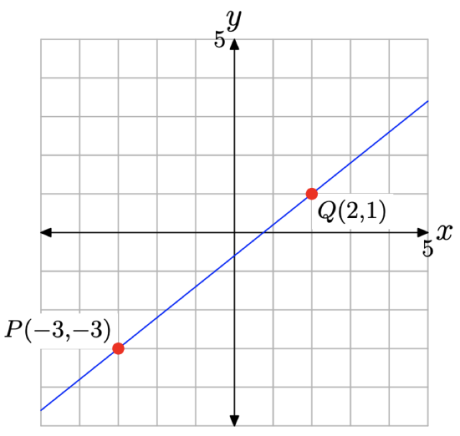
What points are on the line through $(0,1)$ and $(1,4)$? Remember to wrap around.
Compare this with the line through $(0,1)$ and $(2,2)$.

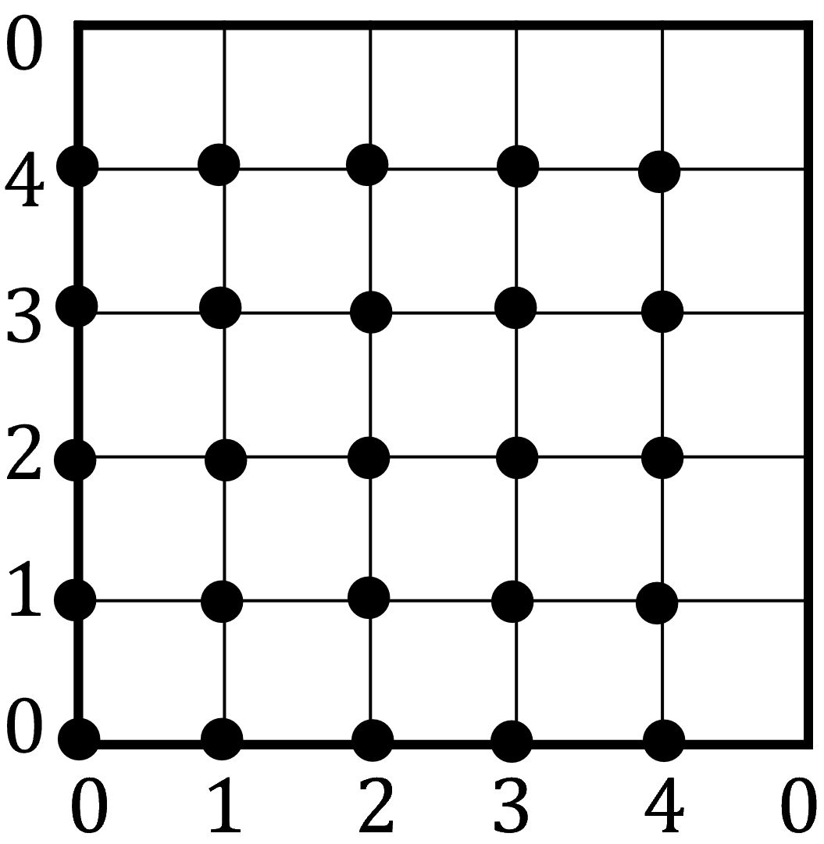
____________________________________________________________________________________

What are the possible points/pictures and lines/cards for the Dobble deck associated with the picture below?
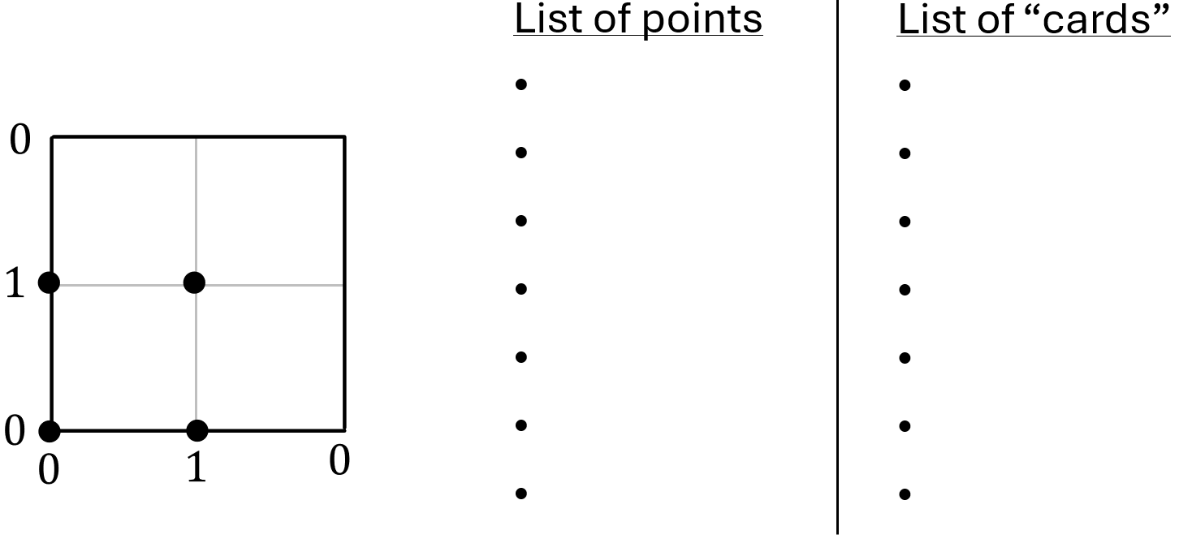
How many points and lines should there be when $N=4$ (so $n=3$).
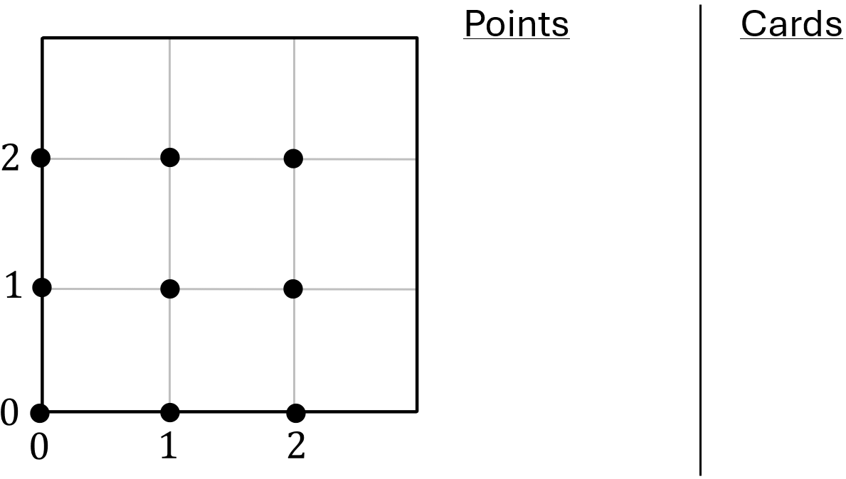

_______________________________________________________________________________

Something goes wrong when $n=4$.
Can you find two lines that don’t intersect?
Can you find two lines that intersect at multiple points?
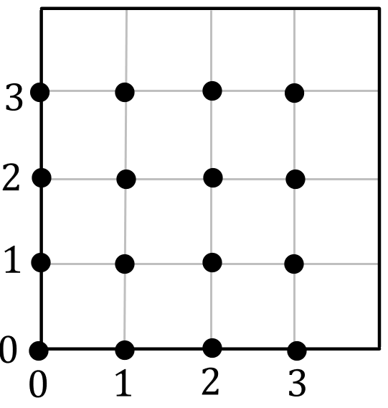
Fill in the multiplication table for $Z_{6}$.
Example: $4⋅5=2$ in $Z_{6}$ because $20÷6$ has a remainder of $2$.
$$×$$ | $$0$$ | $$1$$ | $$2$$ | $$3$$ | $$4$$ | $$5$$
$$0$$
$$1$$
$$2$$
$$3$$
$$4$$
$$5$$

The Spot it! deck ($N=8$)
What points are on the line containing $\left(1,5\right)$ and $(4,3)$?
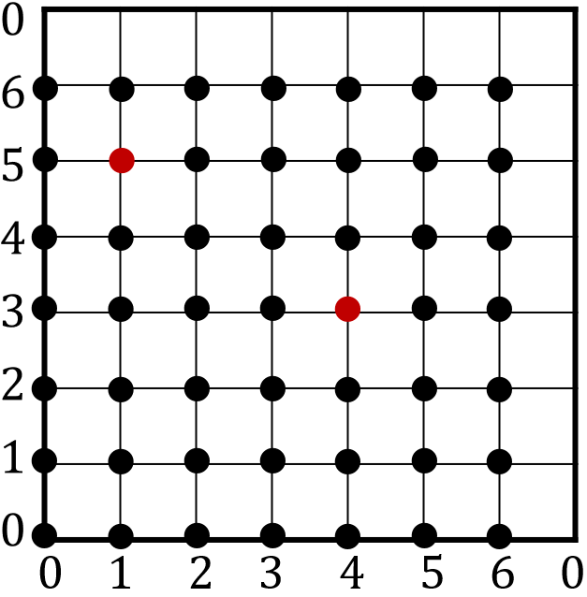
If you’d prefer a grid with actual pictures, you can use this.

I’m not sure what the creator of this image meant by things like “3rd from outermost” so just make your own interpretation and stick with it. Image from https://puzzlewocky.com/games/the-math-of-spot-it/
We can instead think of the cards as points and the lines as pictures.
The cards in the bottom right are the “points at infinity.”
For example, every card in the top row has a lightning bolt, so this horizontal line represents the lightning picture, and the point at infinity with lightning on it is the $slope=0$ card.


Can you determine which slope each point at infinity corresponds to?

This image is a screenshot from https://www.youtube.com/watch?v=VTDKqW_GLkw

